Name: _____________________________________________ Student ID: _________________
BN3402 Bioanalytics for Engineers
Homework Assignment

Goal
The goal of this worksheet is to increase understanding of signal transduction pathways and cell biology techniques by providing you with the opportunity to conduct and analyze data from your own cell biology experiments using StarCellBio.
Learning objectives:
1) Use StarCellBio to obtain experimental results by performing the respective western blotting and microscopy experiments
2) Analyse the results obtained from both experiments to determine the location of Proteins A to E within the cell and regulation of protein activity through phosphorylation
3) Determine the order of Proteins A to E in the signal transduction pathway based on the experimental results obtained

Background Information
You have discovered a new signaling pathway that promotes cell activities and is expressed in all mammalian cells. This pathway is activated by the addition of an extracellular ligand. You have identified five components of this pathway in a human cell line, Proteins A-E, which have not been previously characterized. First, you test the relative protein levels of Proteins A-E before and after pathway activation. You observe that within the time frame in which your experiment is conducted, the levels of Proteins A-E do not change upon the addition of extracellular ligand. Therefore, you determine that within this pathway, Proteins A-E are not regulated through changes in their protein levels. To further characterize this pathway you would like to determine the order of Proteins A-E within this signal transduction cascade by testing the effect of pathway activation on the behavior of Proteins A-E. To do this, you are asked to perform a series of experiments that will allow you to determine the 1. Location within the cell and 2. Regulation of protein activity through changes in phosphorylation about Proteins A-E:
To perform these experiments you are provided with the activating ligand as well as a small molecule inhibitor of this signal transduction pathway, which can bind to and stop the function of certain proteins within the signaling pathway. This inhibitor can be used for experiments testing the location of the protein within the cell, phosphorylation and to order the components of this signal transduction. The following is a summary of the available cell culturing conditions:
Treatment | Description
- Growth media (GM) only | Cells are cultured in GM only and collected.
- GM + ligand | Cells that are grown in GM containing the activating ligand for a given period of time and collected for analysis.
- GM + inhibitor | Cells that are grown in GM containing an inhibitor of the signaling pathway for a given period of time and collected for analysis.
- GM + ligand + inhibitor | Cells that are grown in GM containing the ligand and inhibitor of the signaling pathway for a given period of time and collected for analysis.

1. Microscopy
First, you decide to determine the location of Proteins A-E in the cell prior to and after pathway activation. To do this, you generate human cell lines, each expressing a fusion protein in which Green Fluorescent Protein (GFP) is fused in frame to one of the five proteins. These fusion cell lines are called GFP-Protein A, GFP-Protein B, etc. You then look at the localization of these fusion proteins using fluorescence microscopy and the cell culturing conditions 1 and 2 only. In addition, you are provided with a series of cell lines that can be used as controls to assess the location of proteins in the cell. In these control cell lines the protein fused to GFP has a known location, which does not change upon the addition of the extracellular ligand that activates the signal transduction pathway in question.
Below is a summary of cell lines provided to you:
Strain | Description
GFP-Proteins A, B, C, D and E | Human cell lines expressing Proteins A, B, C, D and E fused to GFP respectively.
GFP-nucleus + cytoplasm | A human cell line expressing GFP, which localizes to both the nucleus and cytoplasm.
GFP- nucleus | A human cell line expressing a protein that localizes to the nucleus, fused to GFP.
GFP– cytoplasm | A human cell line expressing a protein that localizes to the cytoplasm, fused to GFP.
GFP-plasma membrane | A human cell line expressing a protein that localizes to the plasma membrane, fused to GFP.

2. Western Blotting
You successfully determined the location of Proteins A-E within the cell using fluorescence microscopy. However, you are still unclear about the order of Proteins D and E in the new signalling cascade. Hence, you decide to test the phosphorylation status of proteins D and E. As the signaling pathway that you identified is new, you have not yet defined the critical phosphorylation events required for signal transduction. You are fortunate in that there is a commercially available phospho-specific antibody available for one site in each of your proteins. These phospho-antibodies only recognize the phosphorylated form of each protein at that site. You also have an antibody against the housekeeping gene (control), which is not affected by activation of this pathway. You carry out western blotting for the phosphorylated forms of Proteins D and E under the cell culturing conditions 1-4.
Antibody | Description | Expected molecular weight of detected band(s) (kDa)
Anti-phospho-protein D | Antibody recognizing Protein D phosphorylated at a specific site. | 67
Anti-phospho-protein E | Antibody recognizing Protein E phosphorylated at a specific site. | 74
Anti-housekeeping gene (Control) | Primary antibody recognizing a housekeeping gene. | 37
Conduct the appropriate experiments within StarCellBio to determine the effect of pathway activation and inhibition on the location (within a cell) and phosphorylation of Proteins A-E. Using the results that you obtain from these experiments, answer the following questions concerning Proteins A-E and the order of the signal transduction pathway in question.

Accessing StarCellBio
To begin:
1. Using Google Chrome, navigate to: http://starcellbio.mit.edu
2. Click on "Create a Student Account". When you create your account, you will be prompted to enter your email address and password. We recommend that you use your NUS e-mail address. and a + with a number after your name. Create an account using the course code: "BN3402".

Question 1
Using your experimental results, describe the effect of pathway activation on each of the five proteins in the table below by indicating 1) location of the protein in the cell and 2) whether the protein is phosphorylated (by answering “Yes” or “No”, only applicable to Proteins D & E). [1point/answer, total 18 points]
Grading Criteria:
This is a master answer key containing all possible correct data points from the two available data sources. No single student's paper will match this key perfectly.
1. Students Following Instructions (WB only for D & E):
- Students were only required to fill in 18 blanks (all "Location" rows and the "Phosphorylation" rows for D & E).
- "Location" answers should match this key.
- "Phosphorylation" answers for D & E should match this key.
- Phosphorylation blanks for A, B, and C should be empty.
2. Students Following Slides (WB for all proteins):
- Students likely filled in all 30 blanks (green ink).
- "Location" answers should match this key.
- "Phosphorylation" answers for all proteins should match this key.

 |  | No pathway activation  (-Ligand) | Pathway activation  (+ Ligand) | Pathway activation  (+ Inhibitor) | Pathway activation  (+ Ligand)  (+ Inhibitor)
Protein A | Location in the cell | Cytoplasm | Nucleus | N/A | N/A
 | Phosphorylation (+1 bonus mark if all correct and good logic in 2C) | No | Yes | No | Yes
Protein B | Location in the cell | Plasma membrane | Plasma membrane | N/A | N/A
 | Phosphorylation (+1 bonus mark if all correct and good logic in 2C) | No | Yes | No | Yes
Protein C | Location in the cell | Cytoplasm | Plasma membrane | N/A | N/A
 | Phosphorylation (+1 bonus mark if all correct and good logic in 2C) | No | Yes | No | Yes
Protein D | Location in the cell | Cytoplasm | Cytoplasm | N/A | N/A
 | Phosphorylation | No | Yes | No | Yes
Protein E | Location in the cell | Cytoplasm | Cytoplasm | N/A | N/A
 | Phosphorylation | No | Yes | No | No

Question 2 - Part A
For the current experiment, we do not know the relationship between Proteins A-E and the exercise simply suggests their relative position within the signal transduction pathway. Hence, addition of ligand results in the activation of the pathway and in the expression of genes important for cell activities. Given your experimental results, suggest the most likely order for Proteins A-E within this pathway, starting with the addition of ligand and ending with the resulting gene expression. [5 points]

Grading Criteria:
1. Students Following Instructions (WB only for D & E): Refer to answers in red ink
2. Students Following Slides (WB for all proteins): Refer to answers in green ink

Ligand Protein B Protein C Protein D Protein E Protein A Gene expression
[Need to provide good logic in 2C] Ligand (Any order of A, B, C, D) Protein E Gene expression

Question 2 - Part B
At which point within the pathway does the inhibitor act? [2 points]
Downstream of Protein D and upstream of or inhibiting Protein E.

Question 2 - Part C
Describe the general rationale by which you ordered the signal transduction pathway, using your experimental results to justify your explanation. [5 points]
Protein B – first, ligand’s receptor given that it is constitutively associated with the plasma membrane.
Protein C – second, change in localisation from cytoplasm to plasma membrane upon pathway activation/in the presence of ligand
Protein A – last prior to gene expression, due to its change in localisation upon pathway activation from the cytoplasm to the nucleus where it directly or indirectly activates gene expression
Proteins E and D – cannot be ordered based on localisation data, both localises to cytoplasm and does not change upon pathway activation
To order, use inhibitor experiment / data from the western blot
Addition of the inhibitor upon pathway activation/in the presence of ligand had no effect on Protein D phosphorylation’s, while it prevented Protein E's phosphorylation. Therefore, Protein D is upstream from Protein E in the pathway.

Rationale for Protein B (1 point):
[0.5 pt] Correctly identifies Protein B as first component in pathway.
[0.5 pt] Justifies by stating it is located at plasma membrane, implying it is ligand's receptor.
Rationale for Protein C (1 point):
[0.5 pt] Correctly places Protein C after Protein B.
[0.5 pt] Justifies this by describing its translocation from cytoplasm to plasma membrane upon ligand activation.
Rationale for Protein A (1 point):
[0.5 pt] Correctly identifies Protein A as final protein component, acting just before gene expression.
[0.5 pt] Justifies this by describing its translocation from cytoplasm to nucleus.
Rationale for Ordering D & E (2 points):
[1 pt] Correctly describes Western Blot results for both proteins in the presence of the inhibitor (i.e., D is still phosphorylated, E is not).
[1 pt] Correctly concludes from this evidence that Protein D is upstream of Protein E.

Alternate rubric:
[2 points] Correctly interpreted the inhibitor data: inhibitor blocks E's phosphorylation but not the others (A, B, C, D)
[1 point] Using microscopy data for an early step based on membrane interaction (e.g., C moving to the membrane, or B starting there)
[1 point] Identified A as a later step: correctly identify A's translocation to the nucleus as a late-stage event
[1 point] Coherent synthesis: while potentially flawed due to the contradictory data, represents a reasonable attempt to synthesize their observations

Results of Microscopy Experiments
Controls
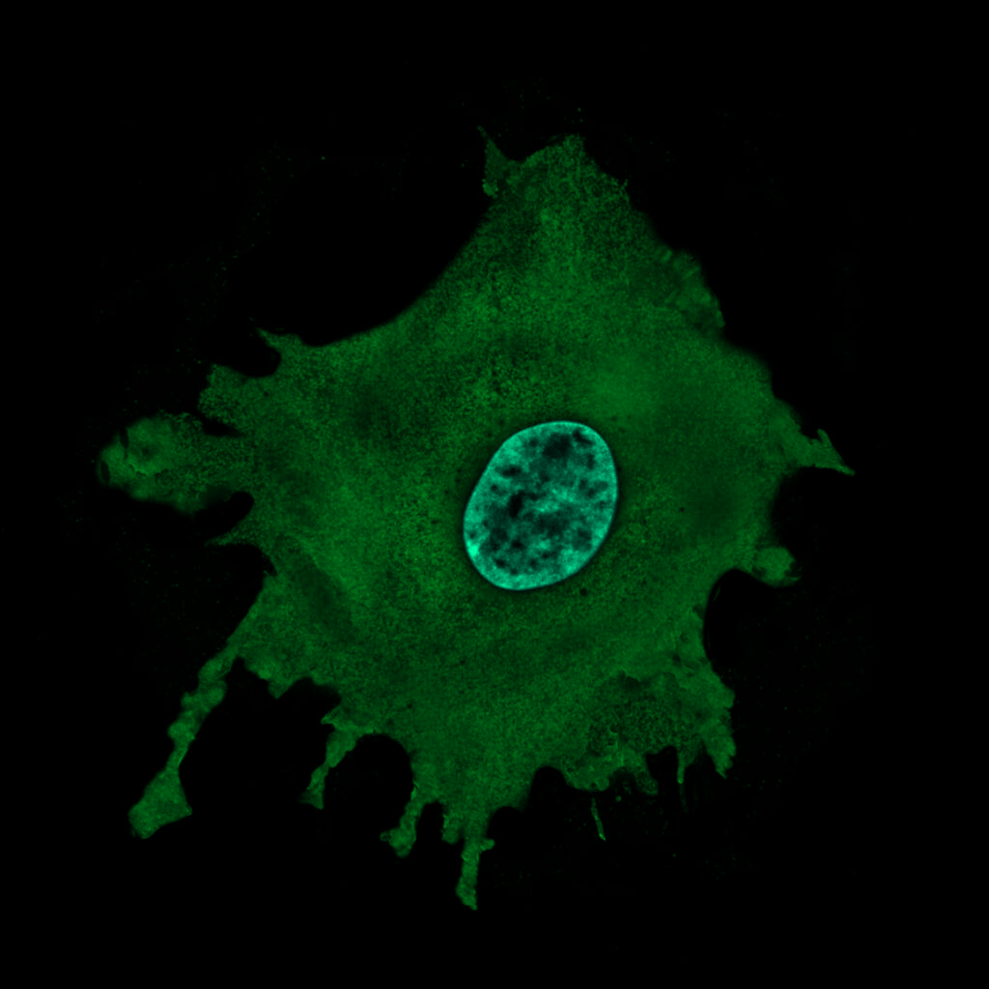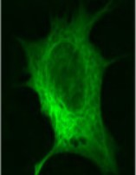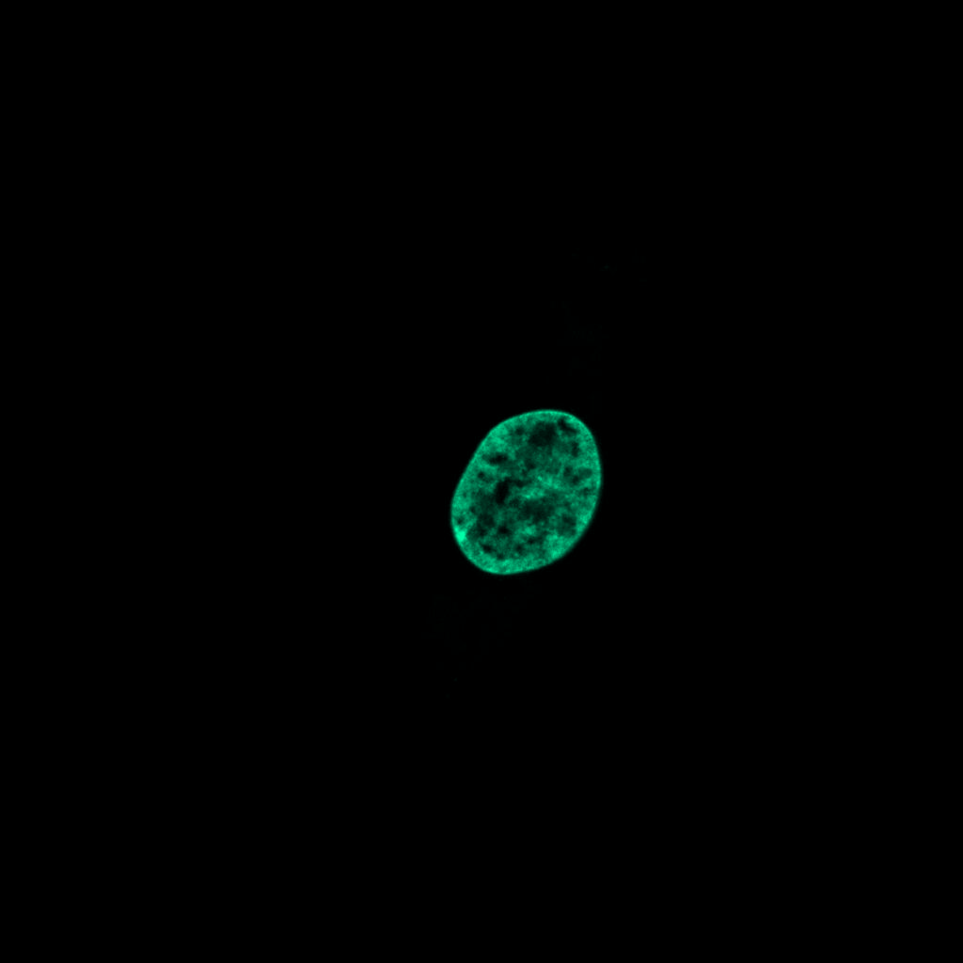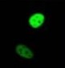
GFP-Nucleus
GFP-Nucleus +Ligand
GFP-Nucleus+Cytoplasm
+Ligand
GFP-Nucleus+Cytoplasm

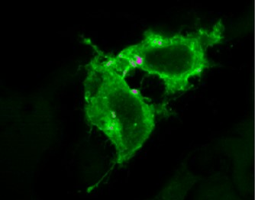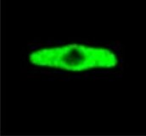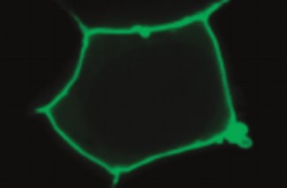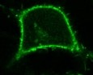
GFP- Plasma Membrane
+Ligand
GFP- Plasma Membrane
GFP-Cytoplasm
+Ligand
GFP-Cytoplasm

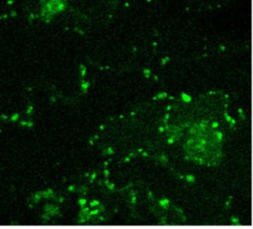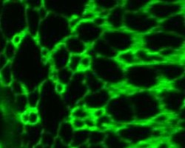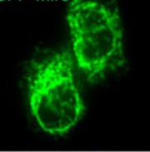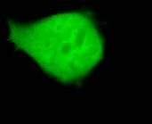
GFP-Mitochondria +Ligand
GFP-Mitochondria
GFP-Golgi Apparatus +Ligand
GFP-Golgi Apparatus

Experimental Groups
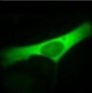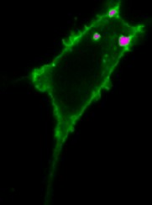
Protein B + Ligand
Protein B
Protein A + Ligand
Protein A

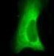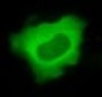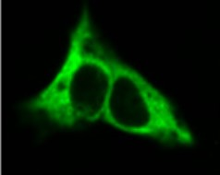
Protein D
Protein D + Ligand
Protein C + Ligand
Protein C

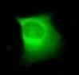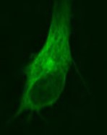
Protein E + Ligand
Protein E
Results of Western Blotting Experiments
- Anti-housekeeping gene (control)
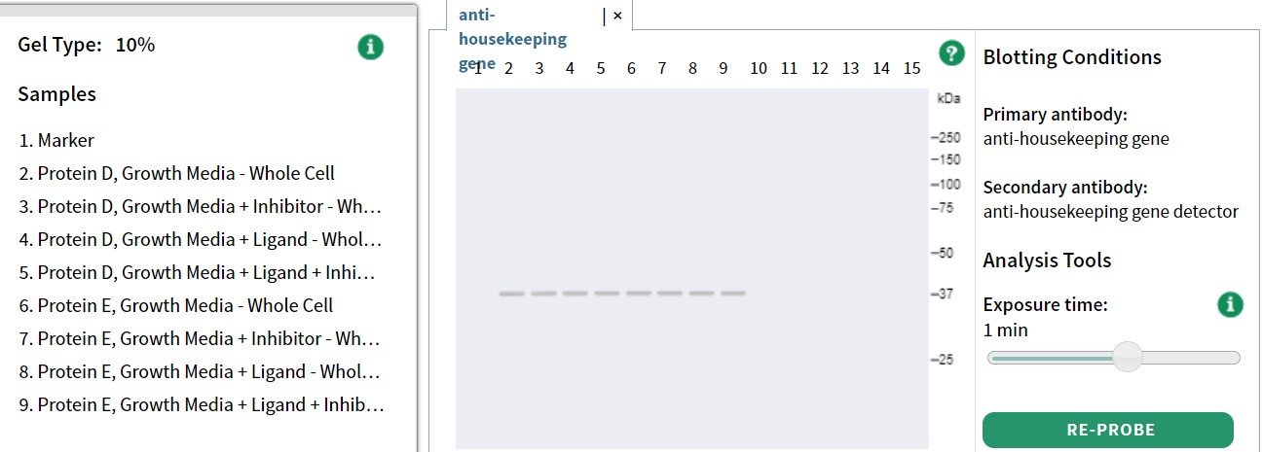
Lane 1: Marker, Lane 2: Protein D + Growth Medium, Lane 3: Protein D + Growth Medium + Inhibitor, Lane 4: Protein D + Growth Medium + Ligand, Lane 5: Protein D + Growth Medium + Ligand + Inhibitor, Lane 6: Protein E + Growth Medium, Lane 7: Protein E + Growth Medium + Inhibitor, Lane 8: Protein E + Growth Medium + Ligand, Lane 9: Protein E + Growth Medium + Ligand + Inhibitor
- Anti-Phospho Protein D
Lane 1: Marker, Lane 2: Protein D + Growth Medium, Lane 3: Protein D + Growth Medium + Ligand + Inhibitor, Lane 4: Protein D + Growth Medium + Inhibitor, Lane 5: Protein D + Growth Medium + Ligand
- Anti-Phospho Protein E
Lane 1: Marker, Lane 6: Protein E + Growth Medium, Lane 7: Protein E + Growth Medium + Ligand + Inhibitor, Lane 8: Protein E + Growth Medium + Inhibitor, Lane 9: Protein E + Growth Medium + Ligand

- Anti-Phospho Protein A
Lane 1: Marker, Lane 2: Protein A + Growth Medium, Lane 3: Protein A + Growth Medium + Ligand + Inhibitor, Lane 4: Protein A + Growth Medium + Inhibitor, Lane 5: Protein A + Growth Medium + Ligand
- Anti-Phospho Protein B
Lane 1: Marker, Lane 6: Protein B + Growth Medium, Lane 7: Protein B + Growth Medium + Ligand + Inhibitor, Lane 8: Protein B + Growth Medium + Inhibitor, Lane 9: Protein B + Growth Medium + Ligand
- Anti-Phospho Protein C
Lane 1: Marker, Lane 10: Protein B + Growth Medium, Lane 11: Protein B + Growth Medium + Ligand + Inhibitor, Lane 12: Protein B + Growth Medium + Inhibitor, Lane 13: Protein B + Growth Medium + Ligand

